My pet is missing – what do I do?

We are sorry to hear that your pet is missing.
The first 24-48 hours are the most critical, and the effort you put in during this critical time will dramatically increase the likelihood that you will recover your pet safely. However, searches can go on much longer than this time period, in many cases. Your ongoing, sustained and proactive involvement is critical to success.
Even if your pet was lost from an unfamiliar area, approximately 80% of the lost pets we help stay within 1 mile of where they went missing (even if this location is hundreds of miles from their home). Using that probability, we will concentrate on this area first. BUT – note that 20% of lost pets travel further – sometimes MUCH further – so you may have to increase your search radius.
The strategy also may be a bit different if your dog is young/healthy, or old/sick/medically compromised, and if your dog is confident/social or shy/skittish. This guide will lead you through the critical steps to take to bring your lost pet home as quickly as possible. We suggest you print out a copy and keep it with you as you go about your lost pet search steps.
Lost Pet Owner Guide
Information Needed (please have ready)
- Photos and description of pet (ex: “four year old Aussie/Border Collie mix, neutered male, not wearing a collar or ID, has a bald spot the size of a dime on their right back outside leg”)
- Address where he went missing from, or closest address to the location (“on the NW corner of the park by the playground, across the street from 143 E. Lucky Lane, Phoenix, AZ, 85004”).
- Was your pet wearing a collar and ID tag, or his he microchipped?
- Circumstances of how he was lost (“The dog was with us on a walk in the park, when a car backfired; I didn’t have a good grip on his leash, and he took off heading Northwest. We tried to call him back but he just kept running.”).
- What is his normal temperament? Shy? Outgoing? Likelihood of him approaching a stranger? (“He is a very nervous dog – he is attracted to children but I doubt he would approach an adult he doesn’t know. If they try to catch him, I believe he would run away.”)
- How long has he been familiar with/lived at the address where he went missing from? (“We just moved into this house about 10 days ago; previously we lived 30 miles away.”)
- If he is accustomed to the area, how often has he gone on walks? (“He has only gone on 2 walks since we moved to this house, both in the last week. Both times, we went to the park and then went around the block, north on Main Ave, east on Central, south on Shady Lane and then west back onto our street, Washington Ave.”)
- Is your dog healthy, or are there any medical issues? (“Our dog is basically healthy however he was only neutered 3 days ago. He still has 7 days of antibiotics left.”)
- Who is your dog closest to? (“The dog stays close to me; he is a bit nervous around my husband or men in general; he sleeps with my 6 year old son and follows him everywhere. He also was in a foster home for a year before we adopted him 3 weeks ago – his foster has come for a visit and he gets SUPER excited to see her!”) In this example, we will not want the husband or males directly calling or approaching of the dog; we may be able to use scent material from the wife, the 6 year old and even the former foster in this search).
- Are there other pets in the home? What is the lost dog’s relationship with these pets? (“We have two other dogs and a cat; he hangs out with one of the dogs; he ignores the other one. The cat keeps to herself, but the dog always follows the cat around and seems very interested in her.”) In this example, we may be able to use scent material from the other dog, and even from the cat – solid waste, litter box, bedding.
- Have there been any sightings? We will need to know the date, time, exact location, and direction of travel. Please also be sure to keep the name and phone number of the person who called in each sightings.
Lost Pet Action Plan
If you can do this safely and there are no other pets or small children to worry about, prop open all yard gates, and even front doors, so that the lost pup can choose to easily return to the yard and home if he so chooses.
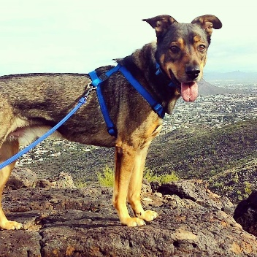STOP doing laundry and cleaning your yard; you will want to preserve all “scent material” which may become very important in the search. This includes not scooping your yard or litter box, and not laundering your pet’s bedding, or even some items of your family’s laundry. Scent is the most powerful sense to an animal, and these scent items can be used strategically (more about this later).
Find a good quality photo of your pet, PREFERABLY one with your pet in a standing or walking position – this photo may be used for lost pet flyers.
Search your home and yard – are you sure your pet isn’t just hiding? Nervous pets – especially cats – can hide in shockingly small areas when frightened. Do a thorough search and don’t forget to look behind dressers, in closets, in and around shrubs, etc.
Set up food and water (we call this a “feeding station”) in your yard. If your pet his hiding close by, this food and water can draw him back. Refresh the food at least once a day, preferably twice. During ant season, make sure all food is ant-proof by placing a heavier food bowl inside a shallow outer pan, and fill that outer pan with water to form an “ant moat.”
Place scent items, such as waste from your dog or items of clothing from a person with whom your dog is bonded, near the feeding station.
Assemble your helpers! Notify all responsible adults, even teens, in your family – recruit close friends or neighbors to assist in the search. This is not the time to be shy – don’t hesitate to ask for help.
Conduct a search on foot or by car. Package up some smelly snacks (not kibble or dry dog treats – make it good!) in a zip lock bag, and take along your pet’s favorite squeaky toy. Begin walking or driving your neighborhood SLOWLY, looking closely in other yards.
Do not have a multitude of people calling out the pet’s name – if 5 different people are calling “Fluffy!” in 5 different areas or on 5 different streets, the pet will have no idea which direction they are supposed to go. Also, calling a pet’s name, clapping or whistling can also trigger a panicked “Oh no – they’re looking for me!” flight response in a pet and can be counterproductive. We recommend that ONLY an owner with whom the pet is bonded should call the pet’s name. Others in the search party should merely search and, when the animal is spotted, notify the owner of the exact location.
If your pet is located, the first priority is to keep the pet calm and do nothing that could drive him into a roadway or other dangerous area. The owner should proceed quickly to the scene with a favorite toy, treats, and a slip leash (or carrier, in the case of a cat). Once on scene, we recommend that the owner sit down, slightly angled away from the pet. The owner should begin talking softly just so the pet can hear their voice and identify them as familiar. Whenever possible, allow the pet to approach the owner. Try not to make any rapid movement or gestures.
If your pet is microchipped, call your microchip company and report him missing! Your veterinarian or the shelter or rescue group from whom you adopted your pet should be able to tell you the name of the microchip company they use, their phone number, and, your pet’s microchip number if you can’t find it.
Online and Social Media Sites
Not a big computer user? Not on social media? That’s ok – recruit a family member, child, grandchild, friend or neighbor to handle this part of the work. Don’t skip it! Many people communicate about lost and found pets on these sites; don’t miss this opportunity to communicate about or search for your lost pet!
Maricopa County Lost and Found Pet Map (https://gis.maricopa.gov/ACC/Stray/index.html) this site will show the location of lost and found cats, and lost and found dogs. All strays who come into MCACC are posted on this site, using the location where they were found. NOTE – this location could be MILES from where your pet went missing so search all listings in a wide area as well.
POST your lost pet on this site as well, so if someone finds your pet or if someone turns your pet into MCACC, staff or citizens can search and see if your pet has been reported missing. NOTE: Pets are only visible on this site for 5 days – keep checking back, and remember to renew your post every 5 days.
Craigslist (“CL”) (https://phoenix.craigslist.org/) – This online ads page is free to use. Check in both the “LOST AND FOUND” and in the “PETS” section. Search for your pet, AND post your pet. Remember that a finder may not accurately guess the breed of your pet so search by other key words instead of just breed. Also, beware of color – you may consider your pet to be “tan”, but someone who may have already found your pet may have listed her as “buff”, “yellow” or “gold”. Posts quickly roll to the bottom so we recommend refreshing your post at least every 2 days.
NextDoor (“ND”) – This smart phone app is also free to use and was created as a way for neighbors in specific areas to communicate with one another. Posts on NextDoor (ND) range from crime reports, to mechanic shop recommendations, to nearby school bake sales, to lost and found pets. In general, only a resident can post or view ND for their specific “neighborhood” and a small range of nearby neighborhoods. If your pet was lost more than 3 miles from where you live, you will want to find a resident near where your pet was lost who is on ND, who can search for posts or post an alert for you. We recommend you draft and send them exactly what you want the message to say.
Facebook (“FB”) – many different lost pet sites can be found on FB – here are a few for the Maricopa County, Arizona area:
Straydar https://www.facebook.com/groups/Straydar/
StraydarAZ https://www.facebook.com/groups/798423246969450/
Straydar Scottsdale/PV/Arcadia https://www.facebook.com/groups/1280153812030349/
Lost Dogs of Arizona https://www.facebook.com/groups/LDOAZ/
Lost Dogs Arizona https://www.facebook.com/LostDogsArizona/
Lost Dogs in Arizona https://www.facebook.com/groups/882932778414854/
Lost Dogs & Cats of Maricopa County https://www.facebook.com/groups/251504341537819/
Lost Cats of Arizona https://www.facebook.com/lostcatsaz/
Lost and Found Pets of Peoria, Glendale, El Mirage, Sun City & Youngtown https://www.facebook.com/groups/1810302072550418/
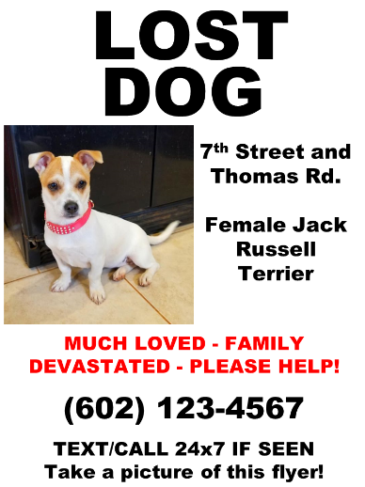Paper Flyers
NOTHING takes the place of basic paper flyers, posted all over your neighborhood! Even if you have posted online and searched all of those posts, you are typically only reaching “pet people” who are active in the animal community. This means that all others who do not have pets and do not follow pet issues will never know you are searching for a pet! Paper flyers will reach moms out for a stroll with babies or toddlers; fitness walkers; people passing casually through a neighborhood; seniors; and kids playing in the neighborhood.
Flyers should be eye catching, simple, printed in color, contain a clear picture and minimal wording, have the phone number of someone who will answer their phone 24/7 and will be extremely thorough about keeping a log of all sightings called in. Flyers can be posted on community mail boxes, bulletin boards, traffic signs, and other locations where people walk or drive by. We suggest placing them in sheet protectors to protect the signs somewhat from inclement weather.
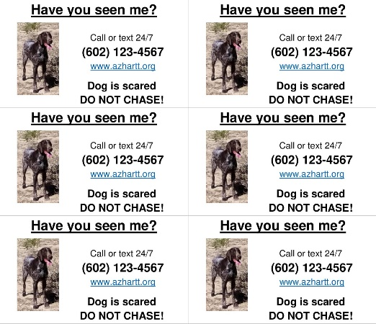Handbills and business cards
These smaller versions of flyers are more suitable for distributing by hand. You can also save printing costs – the handbills are printed 4 per page, and the business card format, 10 per page. Hand these smaller handbills or cards out to:
- Neighbors – go door to door
- Veterinary Clinic, stores and Groomers
- Trash or utility workers
- Joggers, walkers, park goers
Shelter Visits
Maricopa County Animal Care and Control (pets.maricopa.gov)– Pets found West of Central go to the West location, and pets found East of Central go to the East location. Check petharbor.com for posts of animals that come into MCACC, but nothing takes the place of walking the kennels in person. Be sure to ask staff how you can see ALL animals in their care, including those who are not in the public view (animals deemed sick, injured or dangerous). Be sure to bring a copy of your flyer with you.
Arizona Humane Society (www.azhumane.org) – AHS only takes in owner surrenders or sick, injured or underage strays. Be sure to bring a copy of your flyer with you.
Other animal control agencies – check with the animal control department for your city and county, to see if they have picked up a pet matching your pet’s description. Find out where they impound strays that they find.

